Sprint 3 - Agility Design Document

November 29, 2020

Table of Contents
1. Executive Summary 3
1.1 Project Overview 3
1.2 Purpose and Scope of this Specification 3
2. Product/Service Description 3
2.1 Product Context 3
2.2 User Characteristics 3
2.3 Assumptions 3
2.4 Constraints 3
2.5 Dependencies 4
3. Requirements 4
3.1 Functional Requirements 5
3.2 Security 5
3.2.1 Protection 5
3.2.2 Authorization and Authentication 6
3.3 Portability 6
4. Requirements Confirmation/Stakeholder sign-off 6
5. System Design 6
5.1 Algorithm 6
5.2 System Flow 6
5.3 Software 6
5.4 Hardware 6
5.5 Test Plan 7
5.6 Task List/Gantt Chart 7
5.7 Staffing Plan 7

Executive Summary

Project Overview
The product in this project that is being used for test purposes is the Sphero and the intended audience for this project is the Professor that has assigned the project as well as our entire class.

Purpose and Scope of this Specification
In Scope: The focus is for phase 1 of the overall project.
- Making sure that the Sphero can follow the commands of the inputs it is receiving, and then output it as an action.
- View the successes/fails of the Sphero regarding its test in completing a complete figure-8 course.

Out of Scope: Looking at the backend part of this project which involves the overall programming of the Sphero.
- Is the block code ordered and layed out the right way, to give the Sphero proper instruction on what it is supposed to be doing.
- Reviewing the sensor data to make sure that it is also accurate along with the block code.

Product/Service Description
So really overall, it’s just the software to have all the focus and the attention on, as that is the core of the entire success of the project, in more simpler terms, the code is the river and the Sphero is the boat, with the code making sure the boat is instructed and how and where it should be reaching its final destination.

Product Context
The Sphero does relate to other products as it is controlled via a signal from a main control point that could be located on a cpu or server that is being run by code. The Sphero is not independent as it needs clear instruction based off of the code that is being written by the user, however, the Sphero is self-contained. Considering the fact that the code for it is off of its own software application, it is related to a lot of other systems that have the same kind of system that involves writing software to be creating and controlling many things across and outside of the internet. The Sphero EDU Application is the foundation or in other words, the control center for the actual hardware of the Sphero itself. The code is created on the application, and then processed to be inputted or linked into the physical hardware of the object which is outside of the computer, and so signals are sent to the Sphero from the computer to command it to do specific things.

User Characteristics
- College Staff/Students
- Programmers/Engineers
- Tech Experts
- People that create hardware made to have these kinds of capabilities

Assumptions
So really the only things that can affect the project would have to be the algorithm, block coding, or the connection between the software and the hardware. Otherwise if everything is in place then the project should run properly and successfully complete its goals.

Constraints
- The code needs to be right down to the tea and everything needs to be right
- We do have resource constraints regarding limited spacing for the Sphero to move around.
- Difficulty with saving the files for the sensor data and the video recording of the tests
- Access can become confusing when dealing with multiple applications
- Wifi connection needs to be strong in order for signals to successfully travel from software to hardware
- Making sure that the algorithm is correct, otherwise the progress has to be redone if it is wrong

Dependencies
- The hardware will need to have the right software linked to it.
- There needs to be a connection, otherwise there can be no testing.
- Algorithm needs to be on point, depending on what the goal of the test is supposed to be.
- There must be plenty of physical space for the Sphero to move around and complete its tasks.

Requirements

The main requirements needed for the project to run smoothly would have to be a properly set up course for the Sphero to move around in, good connection for the software and hardware to link that way they receive inputs and exert out the outputs, and the correct code to guide the Sphero through its instructions.

- So we have the proper spacing for the Sphero to move around already. Moving forward we do have a secure connection between the software on the computer that would go to the Sphero itself. Finally we do have the correct code put in to follow the algorithm of what the Sphero is supposed to do.
- So the inputs within the system, every last one of them, comes from the algorithm that was designed to command the Sphero. It gets signaled to the actual hardware itself, and then the Sphero goes throughout the output process of doing what the code is telling it to do. And so overall, all of the inputs and outputs that are going through this process then become functions as they become the primary control both between the software and the hardware being used together.

Functional Requirements
Req# | Requirement | Comments | Priority | Date Rvwd | SME Reviewed / Approved
Prior1Part1 | The Sphero must record its movement data for analysis, feedback, and evidence of functioning properly. |  | 1 | 11/29/20 | Yes
Prior1Part2 | The Sphero must operate autonomously from the start of the code lines. |  | 1 | 11/29/20 | Yes
Prior1Part3 | The Sphero must be able to travel a predetermined amount of distance. | Of course it would be determined by the speed it would be going. | 1 | 11/29/20 | Yes
Prior1Part4 | The Sphero must stop after traveling the predetermined amount of distance. |  | 1 | 11/29/20 | Yes
Prior1Part5 | The Sphero must be able to rotate in a different direction accurately measured in degrees. |  | 1 | 11/29/20 | Yes
Prior1Part6 | The Sphero must after completing the tasks stop moving. |  | 1 | 11/29/20 | Yes
Prior1Part7 | The Sphero must change direction over a distance |  | 1 | 11/29/20 | Yes
Prior2Part1 | Code must be efficient to reduce amounts of potential errors. | This would be good to have as it is beneficial | 2 | 11/29/20 | Yes

Security

Protection
- Daily checks on the system as well as the progress made
- Anti-Virus protection
- Any password or 2-step verification
- Setting restrictions to certain parts of the project through the CPU

Authorization and Authentication
The authorization factor would really be through the use of Sphero EDU where the code resides that will be controlling the Sphero at will and for the authentication will be through the status of how the algorithm and code combined will have an effect on the Sphero and the application will portray whether it was a success or not.

Portability
- The program runs on the Sphero
- The software and program are both complied on a computer
- The language being used is java
- The code written makes it completely dependent on its creator
- The language being used is portable
- The main operating system is the computer containing all of the software needed for the Sphero

Requirements Confirmation/Stakeholder sign-off
Meeting Date | Attendees (name and role) | Comments
11/29/20 | Daniel, William, and Stinson | We split priorities and began working individually for certain parts
11/29/20 | Daniel, William, and Stinson | Can confirm that we have completed all tasks

System Design

Algorithm
- Start
- The sphero must travel for 3ft 3in (or a smaller scaled distance)
- The sphero must avoid an obstacle
- The sphero must turn right 90 degrees
- The sphero must travel for 3ft 4in(or a smaller scaled distance)
- The sphero must avoid an obstacle
- The sphero must turn left 90 degrees
- The sphero must travel 3ft 10in (or a smaller scaled distance)
- The sphero must avoid an obstacle
- The sphero must turn right 90 degrees
- The sphero must travel 4ft (or a smaller scaled distance)
- The sphero must jump 1ft (or a smaller scaled distance)
- The sphero must travel 2ft (or a smaller scaled distance)
- The sphero must turn right 135 degrees
- The sphero must travel 9ft
- The sphero must knock over as many pins as it can
- End

System Flow
FLOWCHART IS DOWN BELOW ON NEXT PAGE.

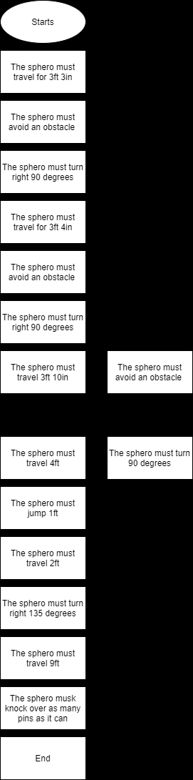

Software
The block code; which is a form of Java Script; was the main software that was used and it was used off of the Sphero EDU application.

Hardware
The Sphero was the main piece of hardware that was used for this entire project and experiment and was also the sole focus of it all regarding collecting data, experimenting, etc.

Test Plan

Reason for Test Case | Test Date | Expected Output | Observed Output | Staff Name | Pass/Fail
To test the code for the agility and see if it would complete its requirements | 11/29/20 | To go through 3 obstacles without hitting them | It hit one of the obstacles | Stinson | Fail
To test the code for the agility and see if it would complete its requirements | 11/29/20 | To go through 3 obstacles without hitting them | It hit one of the obstacles | Stinson | Fail
To test the code for the agility and see if it would complete its requirements | 11/29/20 | To go through 3 obstacles without hitting them | It hit one of the obstacles | Stinson | Fail
To test the code for the agility and see if it would complete its requirements | 11/29/20 | To go through 3 obstacles without hitting them | It hit one of the obstacles and the speed was slow | Stinson | Fail
To test the code for the agility and also fix the speed | 11/29/20 | To go through 3 obstacles and also have the speed be going at what it’s supposed to be | It went through all of the obstacles and also went the speed | Stinson | Pass
To see its turning function | 11/29/20 | For it to turn 90 degrees to the right after the obstacle course | It did not turn at the correct angle | Stinson | Fail
To see its turning function and also give the 90 degree turn to the right | 11/30/20 | For it to turn 90 degrees to the right after the obstacle course | It turned 90 degrees after some trial/error | Stinson | Pass
To see if it would turn 90 degrees to the left | 11/30/20 | The sphero would turn 90 degrees to the left | It did turn 90 degrees to the left | Stinson | Pass
To see if it would turn 90 degrees to the right a second time and then go over a ramp | 11/30/20 | That the sphero would turn 90 degrees to the right a second time and go over a ramp | The sphero turned successfully and went over the ramp | Stinson | Pass
To see if the Sphero would then turn 135 degrees | 11/30/20 | The sphero would turn 135 degrees to the right | The sphero did turn to the right 135 degrees after some trial and error because the robot kept dying | Stinson | Pass
To see if the sphero would complete the whole course | 11/30/20 | For the sphero to complete the course successfully from start to end | The sphero completed the course successfully | Stinson | Pass

Task List/Gantt Chart
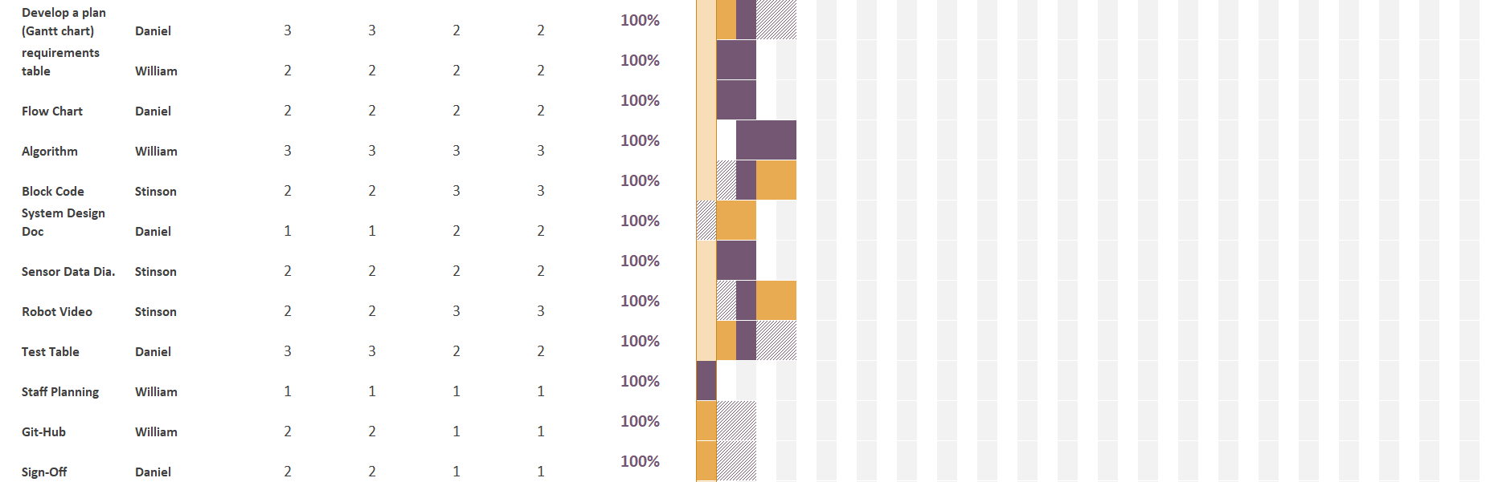

Staffing Plan

Name | Role | Responsibility | Reports To
Daniel McGarry | Data Compiler | Managing time using the gantt chart, making the flow chart, and writing the SDD | Stinson
William Degennaro | Planer | Write the requirements, write the algorithm, make the roles, assign tasks and manage the github repository | Daniel
Stinson Ductan | Developer and Tester | Compiling code, testing, filming and analyzing data for retesting | Daniel

